2nd QC Topics Week3
Live server on VSCode

BSON – Binary encoded format
Used by MongoDB
Is easier to generate and parse for machines and also supports more data types than JSON
HTTP –

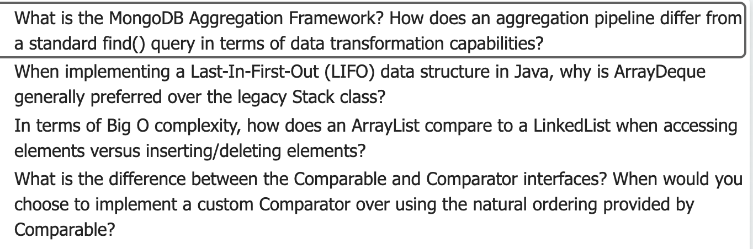
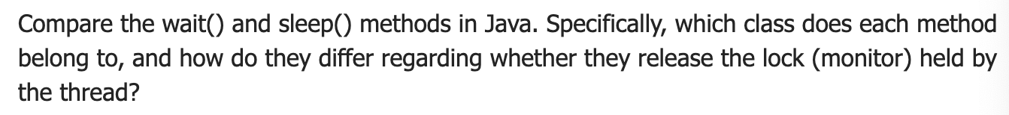
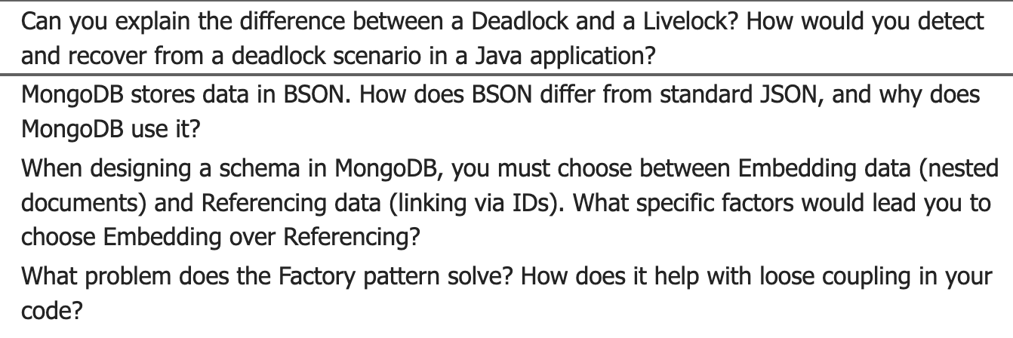
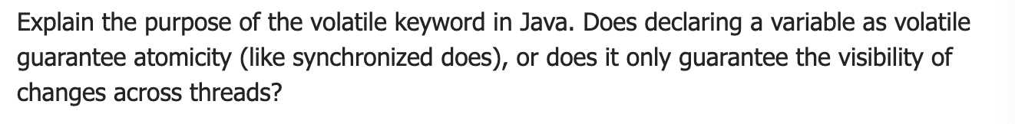
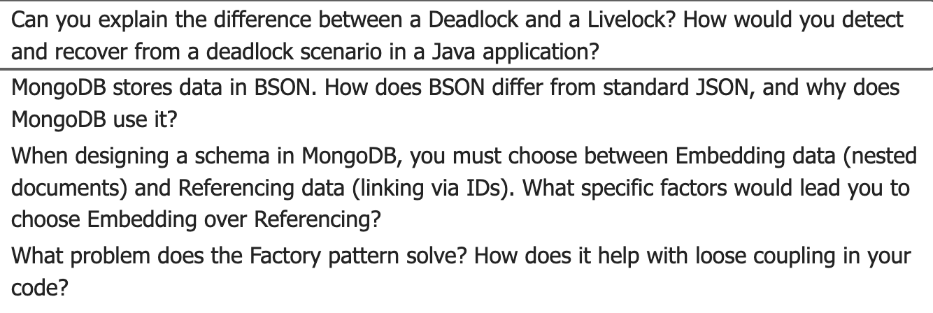
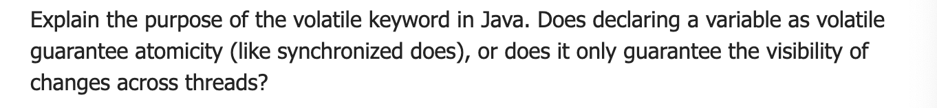
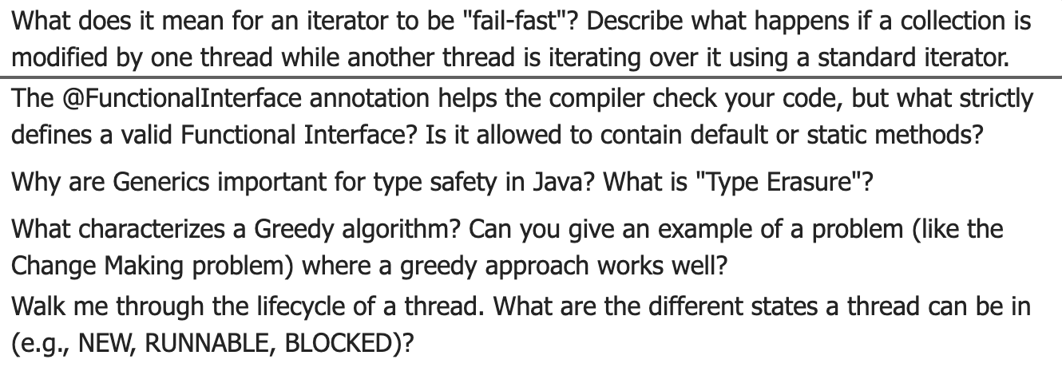
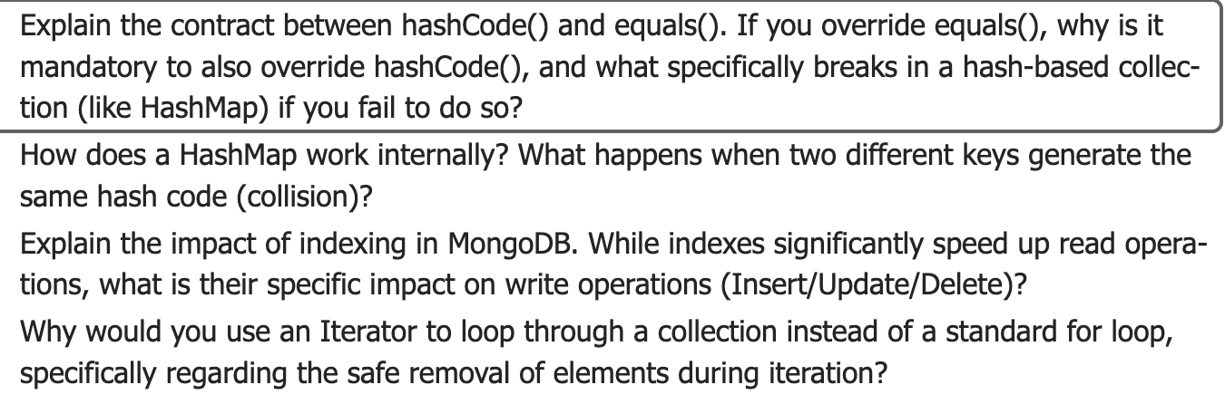
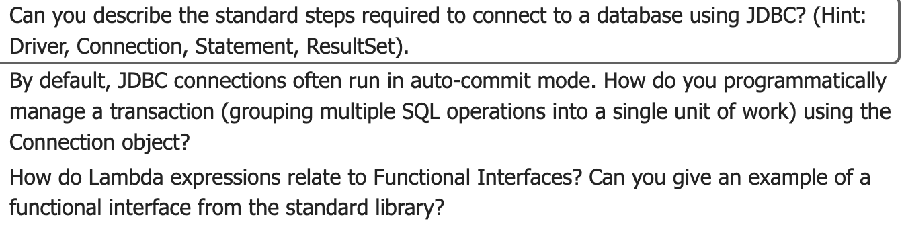
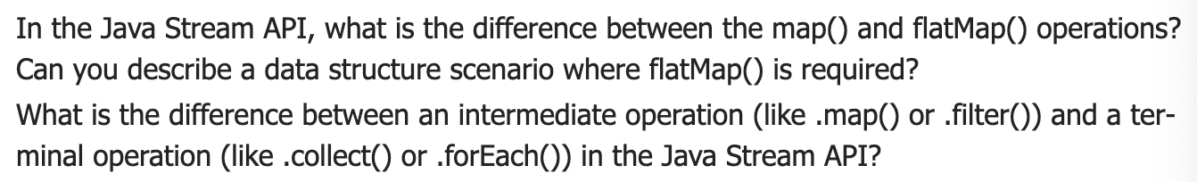
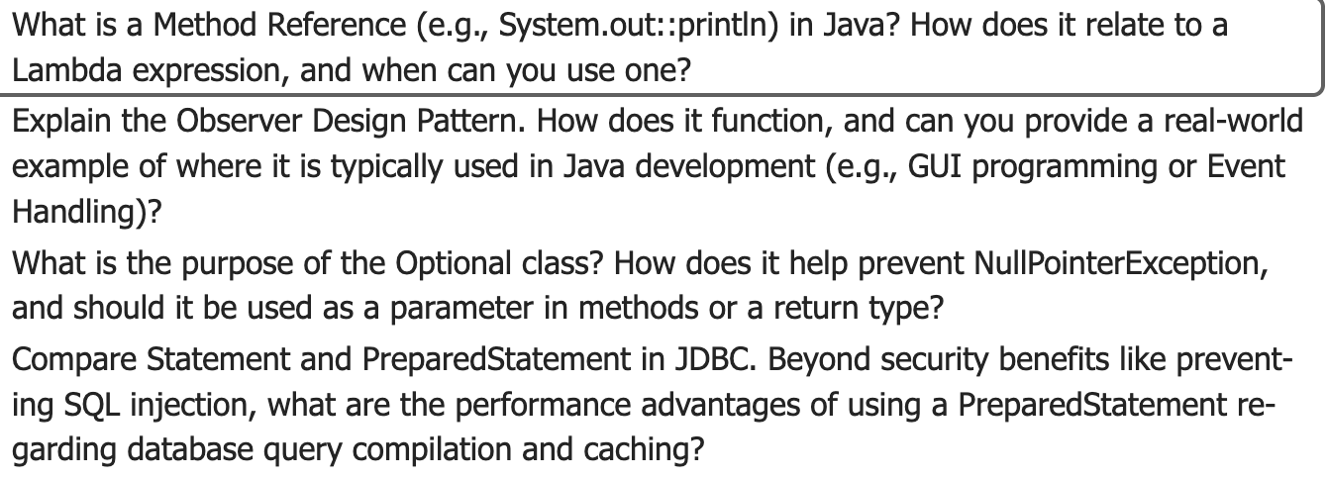
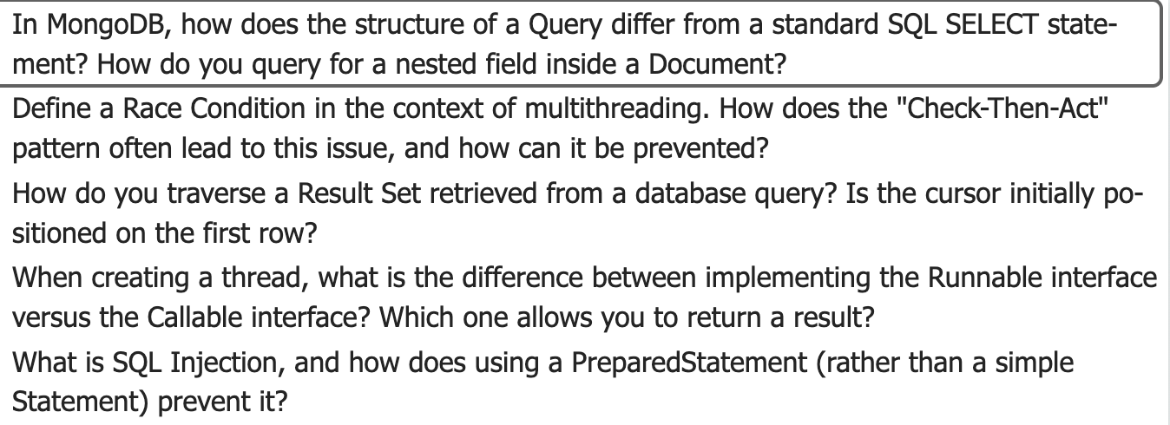

Non-Technical Questions:
Tell me about yourself:
My name is Sidney Gil. I graduated from the University of Texas Rio Grande Valley in May of 2024. I would say I’m most proficient in Java, C++, and Python, and I have worked with tools such as Active Directory, Docker, and Angular. I’ve had hands on experience with at an internship for Walmart where I got to work with databases and create dashboards for endpoint devices so that vendors could see how their devices were being used throughout the company. I most recently got to work with Revature on a project where I am creating a Java program that is able to create and alter Pokémon card deck tables using PostgreSQL. Currently, I am looking for a job where I am able to work in a team and develop even more useful skills that I can put into real world products.

Tell me about your most recent project:

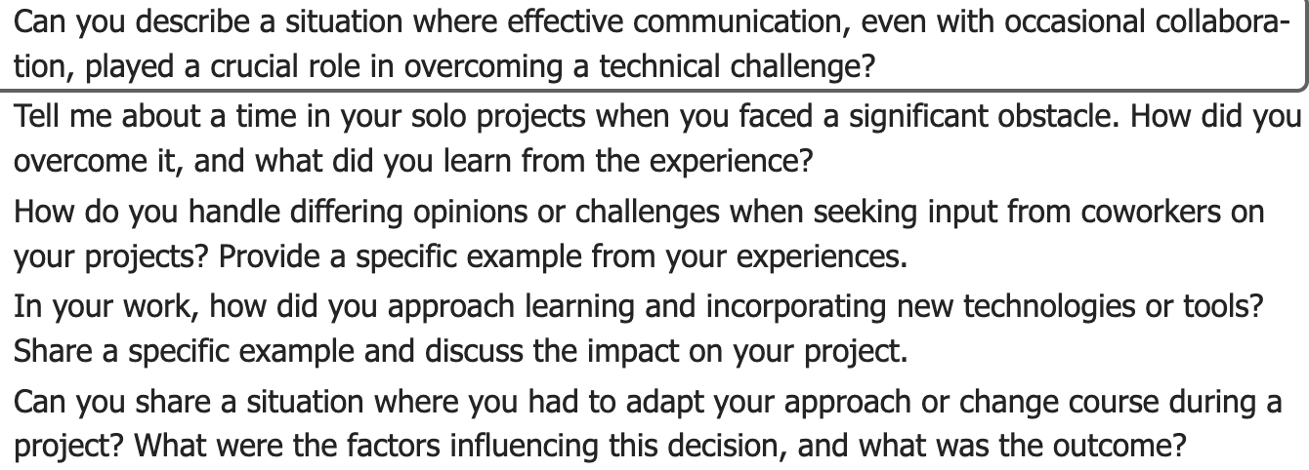

1. MongoDB & NoSQL Cram Sheet

Aggregation Framework vs find()
- find()
  - Simple query + projection.
  - Can filter documents and return matching ones.
  - Limited transformation (mostly field inclusion/exclusion).
- Aggregation Pipeline
  - Chain of stages: $match, $group, $project, $sort, $lookup, $unwind, etc.
  - Can:
    - Group and aggregate (sums, counts, averages).
    - Reshape documents (add/remove/rename fields).
    - Join collections ($lookup).
    - Do multi-step analytics in the DB (similar to SQL GROUP BY, JOIN, window-like operations).
  - More powerful for reporting/analytics and complex transformations.

BSON vs JSON
- JSON
  - Text-based, limited types: string, number, boolean, array, object, null.
- BSON (Binary JSON)
  - Binary format; richer types:
    - ObjectId, Date, Binary, Decimal128, etc.
  - More compact + faster to parse for MongoDB.
  - Designed for efficient storage + transport in the database engine.

Embedding vs Referencing (Schema Design)
- Embedding documents
  - Put related data inside the parent document as subdocuments/arrays.
  - Use when:
    - Strong ownership (e.g., User → Address).
    - “One-to-few” or bounded array size.
    - Data usually read together.
    - You want atomic updates of the whole structure.
- Referencing documents
  - Store foreign key (ID) and keep related data in separate collection.
  - Use when:
    - Many-to-many or “one-to-many with unbounded size”.
    - Related data large or frequently updated independently.
    - Same child referenced by many parents (avoid duplication).

Indexes in MongoDB
- Pros
  - Speed up reads: queries can use index instead of scanning entire collection.
  - Support sorting without in-memory sort (if query uses index order).
- Cons
  - Slower writes:
    - Every insert/update/delete must also update affected indexes.
  - Extra disk and memory usage.
  - Too many indexes = heavy maintenance cost.

MongoDB Query vs SQL SELECT
- SQL
  - SELECT columns FROM table WHERE condition.
  - Tables, rows, fixed schema.
- MongoDB
  - db.collection.find( { filter }, { projection })
  - Query is a document with operators ($gt, $and, etc.).
  - Nested fields via dot notation: "address.city": "Austin".
- Queries for nested fields:
  - Example: db.users.find({ "address.city": "Austin" }).

2. Java Collections & Data Structures Cram Sheet

ArrayDeque vs Stack for LIFO
- Stack
  - Old class; extends Vector.
  - Synchronized methods → slower; considered legacy.
- ArrayDeque
  - Modern, resizable array-based deque.
  - No unnecessary synchronization → faster for single-threaded use.
  - Recommended for stack behavior with push(), pop(), peek().

ArrayList vs LinkedList Complexity
Operation | ArrayList | LinkedList
Random access get(i) | O(1) | O(n) – must traverse
Insert/delete at end | Amortized O(1) | O(1) if at tail
Insert/delete in middle (index) | O(n) – shift items | O(n) – traverse to position
Memory layout | Contiguous array | Nodes with next/prev pointers
- Use ArrayList for frequent random access.
- Use LinkedList when you often add/remove at ends and don’t care about indexed access.

Comparable vs Comparator
- Comparable
  - Implemented by the class itself (compareTo).
  - Defines natural ordering (e.g., String, Integer).
- Comparator
  - Separate object that defines custom order (compare).
  - Passed to sort methods (Collections.sort(list, comparator)).
- Use Comparator when:
  - You can’t modify the class.
  - You need multiple sort orders (by name, then by age, etc.).
  - You want sorting logic outside the model class.

HashMap Internals & hashCode/equals
- How HashMap works
  - Uses hashCode() of key → bucket index.
  - Within bucket: compares keys using equals() to find match.
  - Collisions:
    - Multiple keys with same bucket → linked list or tree of entries.
- hashCode / equals contract
  - If a.equals(b) is true ⇒ a.hashCode() == b.hashCode() must be true.
  - If you override equals(), you MUST override hashCode() accordingly.
  - If violated:
    - Keys become “invisible” in maps/sets (can’t find them).
    - Duplicates or missing entries in HashMap, HashSet.

Iterators & Fail-Fast Behavior
- Iterator advantages
  - Provides generic way to traverse a collection.
  - Safe removal via iterator.remove() during iteration.
- Fail-fast
  - Standard iterators detect structural modification of collection (add/remove) not done through iterator.
  - On detection, they throw ConcurrentModificationException.
  - Intent: signal bugs rather than silently behaving incorrectly.

3. Generics, Functional Interfaces, Lambdas, Optional Cram Sheet

Generics & Type Erasure
- Why Generics
  - Compile-time type safety (List<String> vs raw List).
  - Avoid casts and ClassCastException at runtime.
- Type Erasure
  - Generic type info removed at runtime.
  - JVM sees raw types; generics enforced by compiler.
  - Consequences:
    - Can’t do new T[], instanceof List<String>, or overload solely by generic parameter.

Functional Interfaces & @FunctionalInterface
- Functional Interface
  - An interface with exactly one abstract method.
  - May have:
    - Any number of default methods.
    - Any number of static methods.
- @FunctionalInterface annotation:
  - Optional, but tells compiler to enforce the rule.
- Examples:
  - Runnable (run), Callable<V> (call), Comparator<T> (compare), Supplier<T>, Function<T,R>.

Lambdas & Method References
- Lambda Expression
  - Short syntax for implementing functional interface.
  - Example: Comparator<String> c = (a, b) -> a.length() - b.length();
- Relation to functional interface
  - Lambda body becomes the implementation of the single abstract method.
- Method Reference
  - Shorthand when lambda just calls an existing method.
  - Forms:
    - ClassName::staticMethod (e.g., Math::max)
    - instance::instanceMethod (e.g., System.out::println)
    - ClassName::instanceMethod (e.g., String::compareToIgnoreCase)
  - Use when signature of method matches functional interface method.

Optional
- Purpose
  - Explicitly represent “value may be absent”.
  - Encourage callers to handle “no value” case instead of null.
- Usage patterns
  - As return type: Optional<User> findUser(...).
  - Methods: isPresent(), ifPresent(), orElse(), orElseThrow(), map(), flatMap().
- Best practices
  - Do not use Optional for:
    - Fields in JPA entities, or method parameters.
  - Use it to avoid returning null and to make absence explicit.

4. Concurrency & Threading Cram Sheet

wait() vs sleep()
- sleep(long ms)
  - Static method in Thread.
  - Pauses thread for given time.
  - Does NOT release any monitor/lock.
- wait()
  - Instance method in Object.
  - Must be called inside synchronized block on that object.
  - Releases the monitor; thread goes into WAITING state until notify() / notifyAll() / timeout.

Deadlock vs Livelock
- Deadlock
  - Threads permanently blocked waiting for locks held by each other.
  - No progress; states don’t change.
- Livelock
  - Threads actively change state (e.g., constantly retry) but still make no progress.
- Detection / Recovery
  - Thread dump / monitoring tools to see cycles of lock ownership.
  - Prevention:
    - Consistent lock ordering.
    - Using timeouts.
    - Using higher-level concurrency utilities (e.g., java.util.concurrent locks, semaphores).

volatile vs synchronized
- volatile
  - Guarantees visibility: writes by one thread are immediately visible to others.
  - Prevents reordering around volatile read/write.
  - Does not provide atomicity for compound operations (x++ is still unsafe).
- synchronized
  - Provides mutual exclusion + visibility.
  - Ensures only one thread executes critical section at a time.
  - More overhead (context switching, blocking).

Race Conditions & Check-Then-Act
- Race Condition
  - Outcome depends on timing/interleaving of threads accessing shared state.
- Check-Then-Act pattern
  - Example: if (!list.contains(x)) { list.add(x); }
  - Unsafe if not synchronized: two threads may pass contains check and both add.
- Prevention
  - Synchronize entire check+act block.
  - Use ReentrantLock or atomic classes (e.g., ConcurrentHashMap, AtomicInteger).

Thread Lifecycle States
- NEW – created but not started.
- RUNNABLE – eligible to run (running or ready).
- BLOCKED – waiting for monitor lock.
- WAITING / TIMED_WAITING – waiting for condition/timeout (wait, join, sleep).
- TERMINATED – run finished.

Runnable vs Callable
- Runnable
  - void run(), cannot throw checked exceptions.
  - No return value.
- Callable
  - V call() throws Exception.
  - Returns a result; used with Future / ExecutorService.submit.
- Use Callable when you need a result or checked exceptions.

Synchronization & Performance
- Benefits
  - Prevents race conditions.
  - Ensures consistent view of shared data.
- Cost
  - Blocking/waiting threads.
  - Context switching + contention.
  - Can hurt scalability if overused.

5. Algorithms & Patterns Cram Sheet

Greedy Algorithms
- Idea
  - Make the locally optimal choice at each step; hope it leads to global optimum.
- Works well when
  - Problem has greedy-choice property and optimal substructure.
  - Example: Change Making with US coins {1, 5, 10, 25} – greedy of largest coin first works.

Factory Pattern
- Problem it solves
  - Avoids new scattered everywhere; centralizes object creation.
  - Code depends on abstraction (interface) not concrete class.
- How it helps
  - Loose coupling & easier unit testing.
  - Easy to switch implementations (e.g., ShapeFactory.create("CIRCLE")).

Observer Pattern
- Participants
  - Subject (Observable): keeps a list of observers, notifies them on state change.
  - Observers: implement an update interface.
- Use cases
  - GUI: button click listeners.
  - Event systems, pub-sub style notifications.

6. Java Stream API Cram Sheet

map() vs flatMap()
- map()
  - 1 input → 1 output element.
  - Example: Stream<String> names → Stream<Integer> lengths.
- flatMap()
  - 1 input → many outputs, then flattened.
  - Example: Stream<List<Integer>> → Stream<Integer> by flatMap(List::stream).
  - Needed when mapping each element to a stream/collection and you want a single combined stream.

Intermediate vs Terminal Operations
- Intermediate
  - Return another Stream, lazy.
  - Examples: filter, map, flatMap, sorted, distinct, limit.
- Terminal
  - Trigger pipeline execution, return non-stream result or side-effect.
  - Examples: collect, forEach, reduce, count, anyMatch, findFirst.

Lambdas + Method References in Streams
- Streams frequently accept functional interfaces:
  - map(Function), filter(Predicate), forEach(Consumer), etc.
- Method references are shorter forms when possible:
  - forEach(System.out::println);
  - map(String::toUpperCase);

7. JDBC & SQL / Security Cram Sheet

Standard JDBC Steps
- Obtain connection: DriverManager.getConnection(...).
- Create Statement or PreparedStatement.
- Execute query or update.
- Process ResultSet (for queries).
- Close ResultSet, Statement, and Connection.

Transactions & Auto-commit
- Auto-commit (default)
  - Every SQL statement is its own transaction.
- Manual transaction
  - conn.setAutoCommit(false);
  - Execute multiple statements.
  - conn.commit(); on success, conn.rollback(); on failure.
  - Group multiple operations into one atomic unit of work.

Statement vs PreparedStatement
- Statement
  - SQL as plain string.
  - Susceptible to SQL injection if concatenating user input.
  - Re-parsed each time.
- PreparedStatement
  - SQL with placeholders (?).
  - Parameters set with setter methods.
  - Benefits:
    - Prevents SQL injection (parameters not treated as SQL).
    - Prepared query can be compiled once and reused → better performance.
    - Type-safe parameter binding.

SQL Injection
- What it is
  - Attacker injects SQL via user input to alter query (e.g., OR 1=1).
- Prevention
  - Use PreparedStatement with parameter placeholders.
  - Never concatenate raw user input into SQL string.

ResultSet Traversal
- After executing query, ResultSet cursor:
  - Initially before the first row.
  - You must call rs.next() to move to the first row.
- Typical loop:
- while (rs.next()) {
- // read columns
- }

SQL vs NoSQL (relational vs MongoDB)
- Relational (SQL)
  - Tables, rows, columns, fixed schema.
  - Strong consistency, joins, ACID transactions.
- NoSQL / MongoDB
  - Collections of JSON-like documents.
  - Flexible schema; good for rapidly evolving data models.
  - Scales horizontally easily; data often denormalized (embedded).
- Choose NoSQL when
  - Schema needs to be flexible.
  - Large, high-velocity data.
  - Read patterns fit document model (lots of nested data).

MongoDB & NoSQL
What is the MongoDB Aggregation Framework, and how is it different from a normal find() query?
it’s a pipeline of stages (e.g., $match, $group, $project, $sort, $lookup) that can transform and group documents, similar to SQL GROUP BY/JOIN. A find() just filters and projects existing documents; aggregation can reshape, aggregate, and combine data in multiple steps.

MongoDB & NoSQL
How does BSON differ from JSON, and why does MongoDB use it?
BSON is a binary format that extends JSON with extra types (e.g., ObjectId, Date, Binary, Decimal128) and is more compact and faster for the server to parse. MongoDB uses BSON for efficient storage and transmission plus richer type support than plain text JSON.

MongoDB & NoSQL
When designing a MongoDB schema, when would you embed documents instead of referencing them?
Embed when there is strong ownership and data is usually read together (e.g., order with its line items), the related data is “one-to-few” or bounded, and you want atomic updates of the whole structure. Reference when relationships are many-to-many, child objects are large or shared, or the collection size is unbounded.

MongoDB & NoSQL
How do indexes in MongoDB affect reads and writes?
Indexes speed up reads by letting queries search a smaller, sorted structure instead of scanning the whole collection. They slow writes because each insert, update, or delete must also update any affected index entries and they consume extra disk and memory.

MongoDB & NoSQL
How is a MongoDB query structured differently from a SQL SELECT?
SQL uses text like SELECT cols FROM table WHERE condition. MongoDB uses a query document: db.collection.find({ filter }, { projection }), with operators like $gt, $and. Nested fields are accessed using dot notation, e.g. { "address.city": "Austin" }.

Java Collections & Data Structures
Why is ArrayDeque preferred over Stack for a LIFO structure in modern Java?
Stack is a legacy, synchronized class extending Vector, making it slower and less flexible. ArrayDeque is unsynchronized, resizable, and provides efficient push/pop/peek, so it’s recommended for stack usage in single-threaded or externally synchronized code.

Java Collections & Data Structures
Compare ArrayList and LinkedList in terms of Big-O complexity.
ArrayList: O(1) random access, amortized O(1) append, but O(n) insert/delete in middle (shifting elements). LinkedList: O(n) random access (must traverse), O(1) insert/delete at known ends or node, but still O(n) to reach a given index.

Java Collections & Data Structures
What is the difference between Comparable and Comparator?
Comparable<T> is implemented by the class itself and defines its natural order via compareTo. Comparator<T> is a separate object that defines a custom order via compare and can be passed to sort methods. Use a Comparator when you need multiple sort orders or can’t modify the class.

Java Collections & Data Structures
How does a HashMap work internally, and what happens on collisions?
It uses the key’s hashCode() to choose a bucket index. Within that bucket, it linearly or tree-searches entries and compares keys with equals(). If two keys produce the same hash/bucket, they collide and share the bucket; equals() distinguishes them.

Java Collections & Data Structures
Why must you override hashCode() when you override equals() in a class used as a HashMap key?
The contract requires equal objects to have equal hash codes. If equals() says two keys are equal but their hash codes differ, they end up in different buckets; the map can’t find or de-duplicate them, breaking lookups and causing inconsistent behavior.

Java Collections & Data Structures
What does “fail-fast” mean for Java iterators?
If a collection is structurally modified outside the iterator after its creation, the iterator quickly throws ConcurrentModificationException rather than silently producing incorrect results.

Java Collections & Data Structures
Why might you choose an Iterator over a for loop over indices?
Iterator abstracts the traversal for all collection types (even those without efficient indexing like LinkedList) and allows safe removal of elements during iteration via iterator.remove().

Generics, Functional Interfaces, Lambdas, Optional
Why are generics important, and what is “type erasure”?
Generics add compile-time type safety (e.g., List<String>), reducing casts and runtime ClassCastException. Type erasure means generic type info is removed at runtime; the JVM mostly sees raw types, which is why you can’t do new T[] or check instanceof List<String>.

Generics, Functional Interfaces, Lambdas, Optional
What defines a valid Functional Interface in Java?
Exactly one abstract method; it may have any number of default or static methods. The @FunctionalInterface annotation simply makes the compiler enforce this rule.

Generics, Functional Interfaces, Lambdas, Optional
How do lambda expressions relate to Functional Interfaces?
A lambda is a concise way to provide an implementation for the single abstract method of a functional interface. The lambda’s parameter and return types must be compatible with that method’s signature.

Generics, Functional Interfaces, Lambdas, Optional
What is a Method Reference, and when can you use one?
It’s shorthand for a lambda that just calls an existing method, e.g. System.out::println. You can use one when the target method’s signature matches the functional interface method (static, specific instance, or instance of the type being operated on).

Generics, Functional Interfaces, Lambdas, Optional
What is the purpose of Optional, and how does it help avoid NullPointerException?
Optional<T> explicitly models a “maybe present” value. Instead of returning null, a method returns Optional.empty() or Optional.of(value), forcing callers to handle absence via orElse, ifPresent, etc., which reduces accidental dereferencing of null.

Concurrency & Threading
How do wait() and sleep() differ in Java?
sleep(ms) is a static method in Thread that pauses execution without releasing locks. wait() is an instance method of Object that must be called in a synchronized block; it releases the monitor and waits until another thread calls notify()/notifyAll() or a timeout occurs.

Concurrency & Threading
What is a deadlock, and how does it differ from a livelock?
In a deadlock, threads are permanently blocked each holding resources another needs; nothing progresses. In a livelock, threads are active and constantly changing state (e.g., continuously retrying) but still make no progress (they keep getting in each other’s way).

Concurrency & Threading
What guarantee does the volatile keyword give?
It guarantees visibility—writes to a volatile variable by one thread are immediately visible to other threads and prevents certain reordering. It does not make compound operations (like x++) atomic; you still need synchronization or atomics for that.

Concurrency & Threading
How does the synchronized keyword help with thread safety, and what is its cost?

It enforces mutual exclusion and visibility: only one thread can execute a synchronized block on the same monitor at a time, and updates are made visible to others when the lock is released. The cost is contention, context switching, and potential blocking, which can reduce performance and scalability.

Concurrency & Threading
What is a race condition, and how does the “Check-Then-Act” pattern cause one?
A race condition occurs when the correctness of an operation depends on the timing of threads accessing shared state. In Check-Then-Act (if (!exists) { create(); }) two threads can both pass the check before either acts, leading to duplicate or inconsistent state unless the check and act are performed atomically (e.g., inside a synchronized block).

Concurrency & Threading
What are the main states of a Java thread during its lifecycle?
NEW (created, not started), RUNNABLE (running or ready), BLOCKED (waiting for a monitor lock), WAITING/TIMED_WAITING (waiting for another thread’s action or a timeout), and TERMINATED (finished execution).

Concurrency & Threading
What is the difference between Runnable and Callable?
Runnable’s run() returns void and cannot throw checked exceptions; Callable<V>’s call() returns a value and can throw checked exceptions. Callable is used with ExecutorService.submit() to obtain a Future result.

Algorithms & Design Patterns
What characterizes a Greedy algorithm, and when does it work well?
It makes the locally optimal choice at each step, hoping for a global optimum. It works when the problem has the greedy-choice property and optimal substructure—for example, making change using standard US coin denominations by always taking the largest coin that fits.

Algorithms & Design Patterns
What problem does the Factory pattern solve?
It centralizes and abstracts object creation so that code depends on interfaces or abstract classes, not concrete implementations. This improves loose coupling, testability, and makes it easy to swap implementations (e.g., different repository types) without changing client code.

Algorithms & Design Patterns
How does the Observer pattern work, and where is it used?
A subject maintains a list of observers and notifies them when its state changes (usually by calling an update method). It’s used in event systems like GUI frameworks (button listeners), messaging, and other pub-sub scenarios.

Java Stream API & Functional Style
What is the difference between map() and flatMap() in the Stream API?
map() transforms each element into exactly one element (1→1). flatMap() transforms each element into a stream or collection and then flattens them into a single stream (1→0..n), e.g., from Stream<List<T>> to Stream<T>.

Java Stream API & Functional Style
What is the difference between an intermediate and a terminal operation in Streams?
Intermediate operations (like map, filter, sorted) are lazy and return another stream; they describe the pipeline. Terminal operations (collect, forEach, reduce, count) trigger execution and produce a non-stream result or side effects.

Java Stream API & Functional Style
How do lambdas and method references integrate with Streams?
Streams rely on functional interfaces (e.g., Function, Predicate, Consumer) for operations like map, filter, forEach. Lambdas or method references are passed as implementations of these interfaces, making stream pipelines concise and expressive.

JDBC, SQL & Security
What are the standard steps to connect to a database using JDBC?
Get a Connection (e.g., via DriverManager.getConnection), create a Statement or PreparedStatement, execute a query or update, process the ResultSet (for queries), and finally close the ResultSet, statement, and connection.

JDBC, SQL & Security
How do you manage transactions when auto-commit is on by default?
Disable auto-commit with conn.setAutoCommit(false), execute multiple SQL statements as a unit, then call conn.commit() on success or conn.rollback() on failure, and optionally re-enable auto-commit.

JDBC, SQL & Security
What are the main differences between Statement and PreparedStatement?
Statement executes raw SQL strings and is more prone to SQL injection when concatenating user input. PreparedStatement uses SQL with ? placeholders and separate parameter binding, which helps prevent SQL injection and allows the database to precompile and cache the query for better performance.

JDBC, SQL & Security
What is SQL Injection, and how does PreparedStatement help prevent it?
SQL injection is when user input is interpreted as executable SQL, letting attackers modify queries (e.g., OR 1=1). PreparedStatement sends the SQL and parameters separately; parameters are treated as data, not code, so injected text cannot change the query structure.

JDBC, SQL & Security
How do you traverse a ResultSet from a query? Where is the cursor initially?
After execution, the cursor is positioned before the first row. You call rs.next() to move to the first row and repeatedly in a loop:

while (rs.next()) {
// read columns
}

JDBC, SQL & Security
What are key differences between a relational database and a NoSQL database like MongoDB, and when would you choose NoSQL?
Relational DBs use tables with fixed schemas, strong consistency, and joins; NoSQL (MongoDB) uses flexible JSON-like documents, often denormalizes data, and is designed for horizontal scaling. Choose NoSQL when you need flexible schemas, high write throughput, or document-oriented access patterns with lots of nested data.

